https://www.eightforums.com/threads/wintousb-install-and-run-windows-on-a-usb-drive.58616/:
WinToUSB - Install and Run Windows on a USB Drive (eightforums.com)

Information
WinToUSB is a free software that allows you to install and run Windows operating system on a USB hard drive or USB flash drive, using an ISO image or CD/DVD drive as the source of installation.
WinToUSB will go through most of the setup process you would perform on a regular install. This tutorial will only work for installations of Windows XP, Vista, 7, 8, and 8.1. This will not work for installations of Ubuntu, Linux, etc.

Note
Stuff you'll need:
- WinToUSB (freeware)
- an empty external hard drive
- Windows ISO file or installation disc

Contents
Here’s How: 2
1) Download and install WinToUSB from below. 2
2) You should now see this window below. 2
3) You should now see this window below. 3
4) You will now select the partition and the boot partition on the external hard drive. 4
5) WinToUSB will now install the operating system onto your external hard drive. 5
6) Once the installation has completed in WinToUSB, you will want to boot from the external hard drive through BIOS in order to complete the installation. 6
7) Once you have selected the external hard drive above, you will eventually be guided through the personalization portion of the setup. After that, you can add drivers, programs, files, etc. 7
Related Tutorials: 7
• How to Setup "Windows 8 To Go" on a USB Flash Drive or USB Disk in any Windows 7 and Windows 8 7
• How to Create a "Windows To Go" Workspace on a USB Flash Drive in Windows 8 Enterprise 7
• How to Setup and Run Windows 10 on USB Flash Drive 7

Here’s How:

1) Download and install WinToUSB from below.
​​
Once you have installed WinToUSB, open it.

2) You should now see this window below.
Once you have completed the step(s) below, click "Next"
​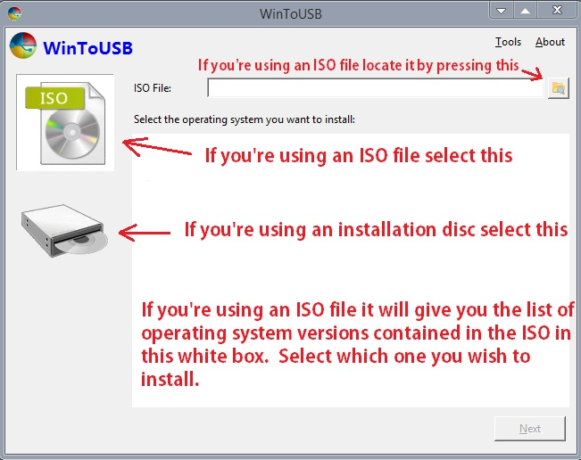

3) You should now see this window below.
Once you have completed the step(s) below, click next.
Note
This will delete all content on the external hard drive.
​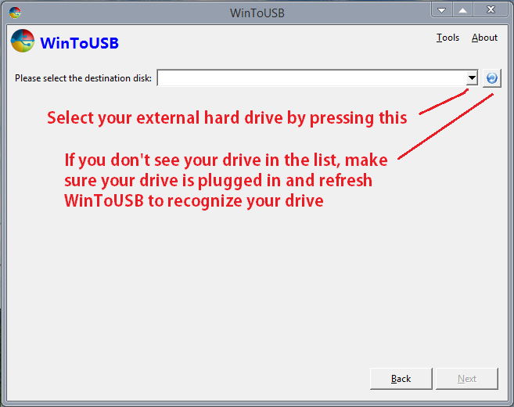

4) You will now select the partition and the boot partition on the external hard drive.
Once you have completed the step(s) below, click "Next".
​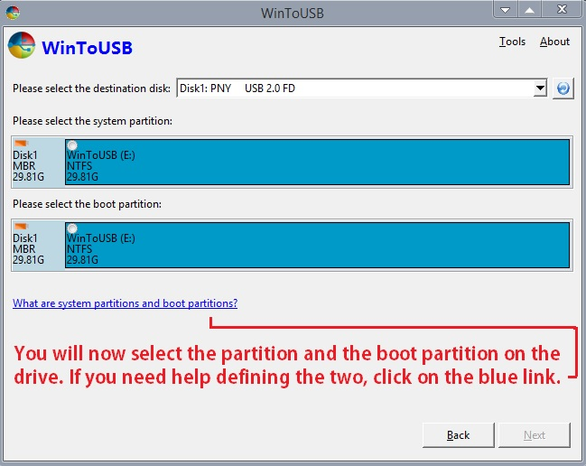

5) WinToUSB will now install the operating system onto your external hard drive.
It could take roughly up to an hour to complete.
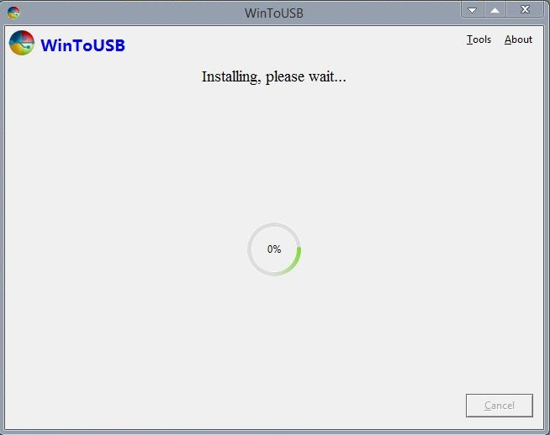
​

6) Once the installation has completed in WinToUSB,
you will want to boot from the external hard drive through BIOS in order to complete the installation.
On my BIOS, I repeatedly hit "Esc" upon startup for the boot menu. Your BIOS will probably differ from mine, so instructions may vary.
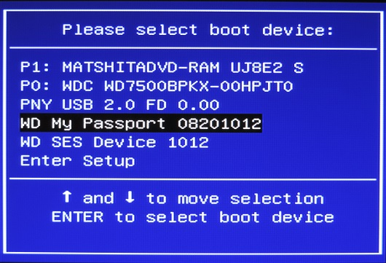

7) Once you have selected the external hard drive above,
you will eventually be guided through the personalization portion of the setup.
After that, you can add drivers, programs, files, etc.

Related Tutorials:

How to Setup "Windows 8 To Go" on a USB Flash Drive or USB Disk in any Windows 7 and Windows 8

How to Create a "Windows To Go" Workspace on a USB Flash Drive in Windows 8 Enterprise

How to Setup and Run Windows 10 on USB Flash Drive

